Nanoparticles at the Solid-Liquid Interface
Lynza C. Halberstadt, Dr. Bruce M. Law, Dr. Christopher M. Sorensen
Department of Physics, Kansas State University

Nanoparticles are becoming more and more a part of daily life so studying their properties is important. One property of any material is surface energy and when placed in a solvent, the nanoparticles can either be on the surface of the solution or in the bulk solvent. The Marangoni effect occurs when nanoparticles are at the surface and is due to a difference in surface energy. The Soret effect is due to temperature differences and occurs when nanoparticles are in the bulk solution. This means that when nanoparticles are on the surface of a solution the nanoparticle solution should follow the Marangoni effect, whereas when nanoparticles are in the bulk solvent the nanoparticle solution should follow the Soret effect. Gold nanoparticles ligated with dodecanethiol appear on the surface when dispersed in octadecane and follow the Marangoni effect as predicted. Cadmium selenide nanoparticles ligated with trioctylphoshine oxide appear in the bulk solvent of octadecane. This predicts that the nanoparticle solution should follow the Soret effect, but instead was found to follow the Marangoni effect.

INTRODUCTION
Nanoparticles. Nanoparticles are important to study because they behave differently than both atoms and larger sized particles. This could be due to the fact that they have a larger surface area to mass ratio than larger sized particles causing them to be more reactive. Nanoparticles are being used it many fields and for many reasons including to identify cancerous tumors, to deliver drugs into the body, to increase battery power and reduce recharge time of lithium-ion batteries, to clean polluted ground water, to make odor-resistant or stain-proof clothing, and to make tennis rackets stronger. In a nanoparticle solution if the surface energy of the nanoparticles is lower than that of the solvent then the nanoparticles will remain on the surface of the solution in order to lower the overall surface energy. When the nanoparticles’ surface energy is lower than that of the solvent then the nanoparticles will stay in the bulk of the solution so as to not raise the surface energy.
Marangoni Effect. This phenomenon was first identified in 1855 by James Thomson, an engineer and physicist from the United Kingdom. However, it is named after the Italian physicist Carlo Marangoni who studied the effect for his doctoral dissertation and published the results in 1865. The Marangoni effect occurs when there is a difference in surface energy between two substances. An example of these two substances is a scenario in which a solution is applied across a temperature gradient so that half of the solution is liquid and half is solid. The temperature Marangoni effect occurs because surface energy is dependent upon temperature. A colder solution has a higher surface energy than a warmer solution. Surface energy is also a force meaning that when a solution is applied across a temperature gradient the larger force, on the colder side, overcomes the lesser force, on the warmer side, and pulls the liquid toward the solid side. The liquid solution then freezes while the force from the solid side continues to pull the liquid side until the entire solution has solidified. The liquid solidifies near the interface and forms a solid “mountain.” The temperature Marangoni effect is strong, but even stronger is the particle Marangoni effect. The particle Marangoni effect occurs then there are nanoparticles located on the surface of a solution. Nanoparticles located on the surface of the solution lower the overall surface energy of the solution. When this solution is applied across a temperature gradient and the solid side freezes, the nanoparticles freeze out before the octadecane. This results in a higher surface energy in the solid half because the surface is now pure octadecane. The force on the solid side pulls even stronger on the liquid side until all the liquid moves over, solidifies, and forms a “mountain” (Figure 1).
A) B)
Figure 1. A) Initial nanoparticle solution in which nanoparticles are at the surface of the solution. B) Mountain building after 8 hours due to the particle Marangoni effect.
Soret Effect. This effect in liquid mixtures was first observed and reported by the German physician and physiologist Carl Ludwig in 1856 and then further understood by the Swiss physicist and chemist Charles Soret in 1879. The Soret effect is a thermodynamic phenomenon occurring in the bulk solvent when mobile particles are placed across a temperature gradient. The positive Soret effect occurs when the larger/heavier particles move to a colder region and the smaller/lighter particles move toward a warmer area, whereas the reverse effect is called the negative Soret effect. The positive Soret effect could be modeled by a nanoparticle solution applied across a temperature gradient in which the solvent moves to the colder side and the nanoparticles move toward the warmer region. The Soret effect is distinguishable from the Marangoni effect by the lack of mountain building activity. Although the Soret effect is not very well understood microscopically, it is still a useful tool in separating a mixed solution or in preventing the mixing of a separated solution.

EXPERIMENTAL METHODS
Chemicals. Octadecane (99%) and anhydrous methanol (99.8%) were obtained from Sigma Aldrich. Solutions of gold nanoparticles ligated with dodecanethiol (Au@DDT) in toluene and cadmium selenide nanoparticles ligated with trioctylphosphine oxide (CdSe@TOPO) in toluene were prepared by Sreeram Cingarapu, a Kansas State University graduate student with the chemistry department.
Solvent Exchange. The solvent in each of the nanoparticle solutions was exchanged from toluene to octadecane. The nanoparticle solutions were sonicated for 1 minute using a Fisher Scientific FS6 Ultrasonic Cleaner. Into two test tubes were added Au@DDT (or CdSe@TOPO) nanoparticle solution (2 mL each tube) and anhydrous methanol (4 mL each tube) because the methanol caused the nanoparticles to precipitate out of the solution. The solutions were then mixed with a Fisher Scientific Vortex Mixer and placed in a centrifuge at around 2500 rpm for 20 minutes. The clear supernatant was discarded and the nanoparticle precipitate was dried under ultra high purity nitrogen gas. Octadecane (1 mL each tube) was added and then the two test tubes were mixed and sonicated until the precipitate was fully dispersed in the new solvent. The two Au@DDT (or CdSe@TOPO) nanoparticle solutions were combined and then separated again into two centrifuge vials. The vials were spun at 14,500 rpm for 10 minutes in a Thermo Scientific Sorvall Legend 14 Personal Microcentrifuge that was heated to 30°C using a Neslab Endocal Refrigerated Circulating Bath. The nanoparticle-rich supernatant was removed from each vial and placed in a dram vial with more octadecane (4 mL), giving a 6mL solution.
Determination of Surface Energy. The surface energy of pure octadecane, Au@DDT in octadecane, and CdSe@TOPO in octadecane was measured using a Hamilton 65RNR 5.0μL Syringe (22s/2”/3). The setup (Figure 2) included a Lake Shore Cryotronics DRC-91C Temperature Controller, Cole Parmer 41723-Series High Intensity Illuminator, heat box, Artray Co. Artcam-103MIBW camera with Navitar 12X High Magnification Zoom Lens, and the program Fta32 installed on a computer. A clean syringe was rinsed 30 times with the desired solution and then 5 μL was taken up to be measured. The syringe was placed in the heat box controlled at 30°C. The program Fta32 was opened on the computer and the “Video” check box was clicked. The syringe was rearranged so that it was focused in the center in the video screen and the tip was a third of the way into the screen. The liquid was dispensed from the syringe so that a drop was hanging from the tip. The “Snap Shot” button was clicked, then “IF Tension.” The IF tension displayed was the measured surface energy.
A)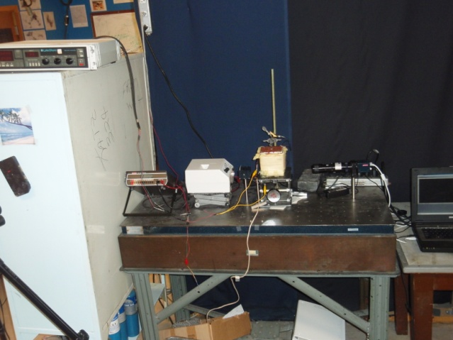 B)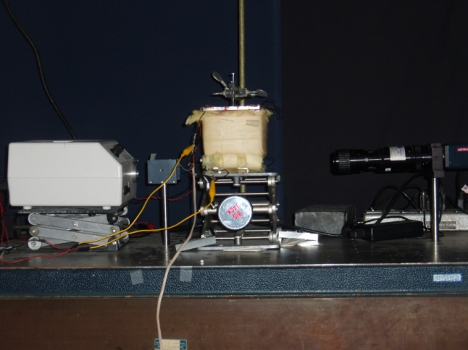
Figure 2. A) View of setup to take surface energy measurements. B) Close up view up camera, heat box, and illuminator.
Mountain Building Measurements. To form the mountains a temperature gradient was applied to the solution from 26°C to 30°C so that half of the solution would be liquid and half solid due to octadecane freezing at 28°C. The setup (Figure 3) included a Melles Griot 05-LHR-141 laser, Konica Minolta DiMAGE A2 camera (side view camera) with DiMAGE Capture computer program, Nikon D90 camera (laser beam camera) with Camera Control Pro 2 computer program, Fisher Scientific Isotemp 1006S water bath circulator, and Wavelength Electronics LFI-3551 temperature controller on a Newport RS 2000 table. The circulating water bath was set to 30°C and then a clean Teflon channel measuring 1.06cm by 5.38cm was placed on an aluminum plate. The channel was attached by Omegatherm High Thermal Conductivity Paste and a triangular level was used to ensure that the channel was level. A needle of known diameter was placed on the channel and the laser beam camera took and saved a picture of the needle. The desired solution (300-400μL) was warmed using a hot plate, sonicated, and then placed in the Teflon channel. The circulating water bath was set to 19.5°C in order to solidify the solution. The temperature controller was set at the 10μA position and set to output 39.6 kΩ. The DiMAGE Capture program was opened on the computer and the camera was focused on the solution. The program was set to save pictures in a certain folder using the “Preferences” button and set to take a total of 48 pictures once every 15 minutes by changing the “Drive Mode” setting from “Single Frame” to “Interval.” Likewise, the Camera Control Plus 2 program was opened on the computer, set to save pictures in a certain folder by clicking “Tools” then “Download Options,” and set to take a total of 48 pictures once every 15 minutes by clicking “Camera” and then “Time Lapse Photography.” After about 30 minutes when the solution was frozen and the temperature of the water bath had cooled to the set temperature of 19.5°C, the temperature controller output was turned on and both cameras were set to start taking pictures.
A)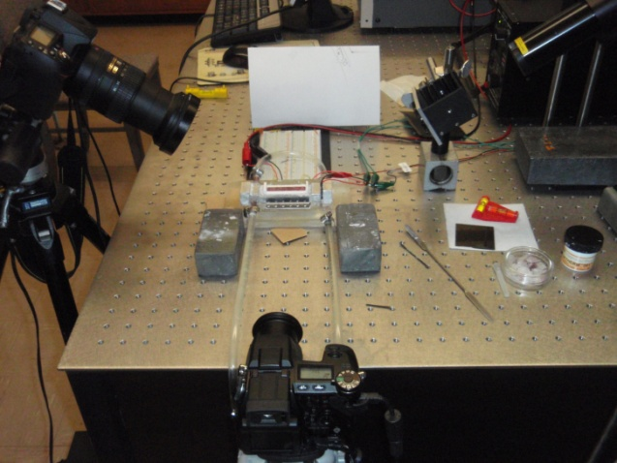 B)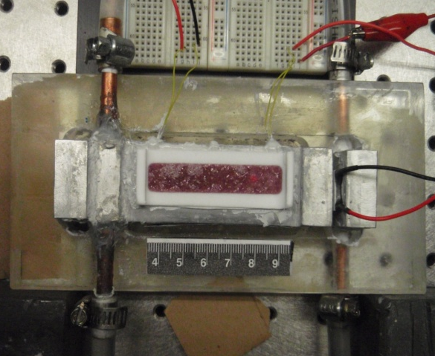
Figure 3. A)View of entire experimental setup. Fisher Scientific Isotemp 1006S water bath circulator was on the floor. B) Close up view of solution in Teflon channel on the aluminum block. Left side was the cold side and right side was the hot side.
Analyzing Mountain Building Data. The laser beam data and side view data were analyzed using the computer program Image-Pro Plus. For the side view data, each picture was moved into the program and the mountain height was measured by clicking “Measure” then “Line Profile.” The line was placed vertically from the top of the Teflon channel to the peak of the mountain and the number of pixels in each mountain height was recorded along with the number of pixels per millimeter in order to convert the mountain height from pixels to millimeters. For the laser beam data, each picture was moved into the program and the center of the laser beam was found with the naked eye. Although the laser beam should only change in the y direction, both the x and y coordinates were recorded for each picture. Each measurement was taken 3 times by placing the mouse in the center of the laser beam and reading the position at the bottom of the screen. The time at which the laser beam hit the Teflon channel, meaning that all liquid was gone, was also noted. The change in y coordinates for each picture was calculated based on the y coordinate of when the laser beam hit bottom. This distance was equal to Y (Figure 4). The number of pixels in the needle diameter was measured and used to convert Y from pixels to millimeters. The volume of liquid remaining was calculated as follows.
V = L x W x D = length of liquid in Teflon channel x width of Teflon channel x Ysinθ
θ
D
Y
liquid
solid
Figure 4. Side view model of how the change in laser beam position was used to find the change in depth of the liquid and therefore the change in volume of the liquid.

RESULTS AND DISCUSSION
Surface Energy Measurements. The surface energy of the pure octadecane was found to be 22.3 ± 0.2 mN/m (n=10). The surface energy of Au@DDT in octadecane was determined to be 18.1 ± 0.2 mN/m (n=10) which implied that the gold nanoparticles were at the surface of the solution. Au@DDT nanoparticles have a lower surface energy than pure octadecane, so when Au@DDT nanoparticles were dispersed in octadecane they preferred to be on the surface of the solution in order to produce a lower overall surface energy. A surface energy of 22.3 ± 0.2 mN/m (n=10) was measured for CdSe@TOPO in octadecane indicating that the nanoparticles were in the bulk solution. CdSe@TOPO nanoparticles preferred to remain in the bulk solution, as opposed to on the surface of the solution, in order to have the lowest possible surface energy overall because CdSe@TOPO nanoparticles have a higher surface energy than pure octadecane.
A) B) C)
Figure 5. A) Model of what pure octadecane looked like. B) Model of what Au@DDT in octadecane looked like. C) Model of what CdSe@TOPO in octadecane looked like.
Mountain Height Measurements. The pictures of the mountain heights were taken every 15 minutes for 12 hours, but only the pictures every 30 minutes for 8 hours were examined. The height of the average mountain from Au@DDT in octadecane grew faster and was significantly higher than the average mountain height of either pure octadecane or CdSe@TOPO in octadecane (Figure 6A). The difference in average mountain height between the pure octadecane and CdSe@TOPO in octadecane was not significantly different. Four trials were done with pure octadecane (Figure 6B) in which three trials produced mountains but the trial on June 23 did not. Three trials were recorded of mountain building with Au@DDT in octadecane (Figure 6C) in which they all produced mountains. Five trials were measured for CdSe@TOPO in octadecane (Figure 6D) in which the trial on July 13 did not produce a mountain but the remaining four did. The average mountain heights (Figure 6A) included only the trials in which mountains were formed. It was unclear why a trial from each of the pure octadecane set and the CdSe@TOPO in octadecane set did not form mountains but it indicated that these two solutions will occasionally, under the correct conditions, follow the Soret effect. Because the majority of the trials of pure octadecane and CdSe@TOPO in octadecane formed mountains, it indicated that these two solutions will usually follow the Marangoni effect. The observation that all of the Au@DDT in octadecane trials formed mountains meant that this solution will always follow the Marangoni effect.
A) B)C) D)
Figure 6. A) Average mountain heights of each Au@DDT in octadecane, pure octadecane, and CdSe@TOPO in octadecane. B) Trials of pure octadecane mountain building. C) Trials of Au@DDT in octadecane mountain building. D) Trials of CdSe@TOPO in octadecane mountain building.
Change in Volume Measurements. The average rate at which the liquid volume decreased was equal to the rate at which the liquid was pulled over onto the mountain and solidified. The average rate at which liquid Au@DDT in octadecane moved toward the cold side and solidified was 53 ± 24 μL per hour (Figure 7A). This was significantly different than the rate of pure octadecane, 16 ± 13 μL per hour, and CdSe@TOPO in octadecane, 16 ± 4 μL per hour. The rates of change in liquid volume of pure octadecane and CdSe@TOPO in octadecane were not significantly different from one another. Four trials of pure octadecane (Figure 7B) were examined in which the trial on June 23 did not form a mountain, meaning that the change in liquid volume was very small, but the remaining three did. All four trials of the change in liquid volume of Au@DDT in octadecane (Figure 7C) formed mountains and had all of the liquid removed within 4 hours. Of the five trials using CdSe@TOPO in octadecane (Figure 7D), four formed mountains but the trial on July 13 did not indicated by the comparatively small change in volume. Because the pure octadecane formed a mountain when applied across a temperature gradient, it followed the temperature Marangoni effect. The Au@DDT in octadecane solution also formed mountains but the rate was much faster meaning that Au@DDT in octadecane followed the particle Marangoni effect because the Au@DDT nanoparticles were on the surface of the solution. The solution of CdSe@TOPO in octadecane behaved very similarly to the pure octadecane with the rate of change of liquid to solid being almost identical. This indicated that CdSe@TOPO in octadecane followed the temperature Marangoni effect just like pure octadecane.
A) B) C) D)
Figure 7. A) Average slope of decreasing liquid volume versus time for Au@DDT in octadecane, pure octadecane, and CdSe@TOPO in octadecane. Lines were normalized to start at 150μL. B) Volume change trials of pure octadecane. C) Volume change trials of Au@DDT in octadecane. D) Volume change trials of CdSe@TOPO in octadecane.

CONCLUSION
It was known that a solution of gold nanoparticles ligated with dodecanethiol (Au@DDT) in octadecane formed a mountain when a temperature gradient was applied across the solution. This was due to the particle Marangoni effect because the nanoparticles were on the surface of the octadecane solvent, as discovered by measuring the surface energy. Pure octadecane also formed a mountain when a temperature gradient was applied due to the temperature Marangoni effect. A solution of cadmiun selenide nanoparticles ligated with trioctylphosphine oxide (CdSe@TOPO) in octadecane was thought to follow the Soret effect. This was because the measured surface energy was the same as pure octadecane indicating that the nanoparticles were in the bulk solvent instead of on the surface. However, it was found that the CdSe@TOPO in octadecane solution did not follow the Soret effect, but rather the temperature Marangoni effect like the pure octadecane. This implied that the bulk solvent had no affect on the observed trend. The only thing that mattered in determining whether the Marangoni effect or Soret effect was observed was the surface composition of the solution.

ACKNOWLEDGEMENTS
Financial support was provided by the National Science Foundation through grant number PHY-0851599. Thanks were also given to Dr. Haeng Sub Wi for his teaching of how to use all of the instruments.
TABLES
 | June 10 | June 22 | June 23 | June 29 | Average
Time (h) | Height (mm) | Height (mm) | Height(mm) | Height (mm) | Height (mm)
0.5 | 0.17 | 0.02 | 0.00 | 0.10 | 0.10
1.0 | 0.49 | 0.09 | 0.06 | 0.25 | 0.28
1.5 | 0.66 | 0.16 | 0.06 | 0.30 | 0.37
2.0 | 0.71 | 0.20 | 0.06 | 0.50 | 0.47
2.5 | 0.80 | 0.31 | 0.06 | 0.73 | 0.61
3.0 | 0.86 | 0.44 | 0.08 | 0.78 | 0.69
3.5 | 0.91 | 0.51 | 0.08 | 0.80 | 0.74
4.0 | 1.11 | 0.55 | 0.08 | 0.90 | 0.85
4.5 | 1.51 | 0.58 | 0.10 | 0.88 | 0.99
5.0 | 1.63 | 0.62 | 0.10 | 0.93 | 1.06
5.5 | 1.74 | 0.69 | 0.10 | 0.93 | 1.12
6.0 | 1.89 | 0.73 | 0.12 | 0.98 | 1.20
6.5 | 1.94 | 0.78 | 0.12 | 1.00 | 1.24
7.0 | 1.97 | 0.82 | 0.12 | 1.05 | 1.28
7.5 | 2.03 | 0.89 | 0.12 | 1.10 | 1.34
8.0 | 2.11 | 0.93 | 0.12 | 1.10 | 1.38
Table I. Raw data of mountain height versus time of pure octadecane mountain building. The average consists of only June 10, June 22, and June 29 data in which mountains were formed.
 | June 30 | July 5 | July 8 | Average
Time (h) | Height (mm) | Height (mm) | Height (mm) | Height (mm)
0.5 | 0.17 | 0.28 | 0.31 | 0.25
1.0 | 1.11 | 0.92 | 0.97 | 1.00
1.5 | 1.50 | 1.36 | 1.53 | 1.46
2.0 | 1.69 | 1.58 | 1.83 | 1.70
2.5 | 1.97 | 1.72 | 1.97 | 1.89
3.0 | 2.28 | 1.83 | 2.17 | 2.09
3.5 | 2.39 | 1.94 | 2.28 | 2.20
4.0 | 2.50 | 2.00 | 2.33 | 2.28
4.5 | 2.64 | 2.14 | 2.47 | 2.42
5.0 | 2.67 | 2.31 | 2.67 | 2.54
5.5 | 2.72 | 2.33 | 2.75 | 2.60
6.0 | 2.75 | 2.36 | 2.81 | 2.64
6.5 | 2.78 | 2.42 | 2.83 | 2.68
7.0 | 2.78 | 2.44 | 2.89 | 2.70
7.5 | 2.78 | 2.44 | 2.92 | 2.71
8.0 | 2.78 | 2.44 | 2.94 | 2.72
Table II. Raw data of height versus time of Au@DDT in octadecane mountain building. No mountain height data was taken on July 11 due to instrument malfunction.

 | July 12 | July 13 | July 14 | July 15 | July 19 | Average
Time (h) | Height (mm) | Height (mm) | Height (mm) | Height (mm) | Height (mm) | Height (mm)
0.5 | 0.14 | 0.05 | 0.05 | 0.02 | 0.11 | 0.08
1.0 | 0.21 | 0.05 | 0.36 | 0.24 | 0.32 | 0.29
1.5 | 0.43 | 0.07 | 0.43 | 0.37 | 0.50 | 0.43
2.0 | 0.60 | 0.09 | 0.57 | 0.46 | 0.57 | 0.55
2.5 | 0.88 | 0.16 | 0.64 | 0.56 | 0.73 | 0.70
3.0 | 1.17 | 0.21 | 0.73 | 0.80 | 1.01 | 0.93
3.5 | 1.29 | 0.21 | 0.80 | 1.05 | 1.12 | 1.06
4.0 | 1.38 | 0.21 | 1.09 | 1.20 | 1.26 | 1.23
4.5 | 1.45 | 0.28 | 1.30 | 1.29 | 1.33 | 1.34
5.0 | 1.52 | 0.33 | 1.45 | 1.37 | 1.42 | 1.44
5.5 | 1.55 | 0.37 | 1.55 | 1.41 | 1.49 | 1.50
6.0 | 1.62 | 0.47 | 1.61 | 1.44 | 1.54 | 1.55
6.5 | 1.64 | 0.51 | 1.68 | 1.56 | 1.61 | 1.62
7.0 | 1.74 | 0.58 | 1.77 | 1.63 | 1.68 | 1.71
7.5 | 1.79 | 0.63 | 1.84 | 1.68 | 1.68 | 1.75
8.0 | 1.88 | 0.67 | 1.91 | 1.76 | 1.72 | 1.82
Table III. Raw data of mountain height versus time of CdSe@TOPO in octadecane mountain building. The average consists of only July 12, July 14, July 15, and July 19 data in which mountains were formed.
 | June 10 | June 22 | June 23 | June 29
Time (h) | Volume (uL) | Volume (uL) | Volume (uL) | Volume (uL)
0.5 | 295.39 | 153.12 | 155.56 | 34.09
1.0 | 291.56 | 151.36 | 145.49 | 34.09
1.5 | 278.51 | 138.34 | 138.36 | 29.22
2.0 | 270.84 | 135.87 | 137.29 | 26.79
2.5 | 257.03 | 131.30 | 133.36 | 25.81
3.0 | 250.89 | 127.07 | 133.08 | 23.87
3.5 | 228.64 | 124.61 | 131.22 | 20.46
4.0 | 211.76 | 122.85 | 124.44 | 20.46
4.5 | 193.73 | 116.51 | 125.16 | 18.51
5.0 | 169.95 | 108.07 | 128.37 | 18.51
5.5 | 148.85 | 104.19 | 124.80 | 13.15
6.0 | 140.79 | 93.29 | 126.58 | 12.66
6.5 | 120.84 | 82.72 | 122.30 | 10.72
7.0 | 107.80 | 77.79 | 120.87 | 11.20
7.5 | 92.84 | 68.64 | 117.66 | 7.31
8.0 | 82.86 | 61.19 | 116.95 | 8.28
8.5 | 65.98 | 45.76 | … | 3.41
9.0 | 52.94 | 39.78 | … | 3.90
9.5 | 38.36 | 31.33 | … | 0
10.0 | 27.62 | 20.42 | …
10.5 | 10.74 | 14.43 | …
11.0 | 0 | 0 | …
Slope of Line | -30.16 | -14.35 | -3.85 | -3.63
Table IV. Raw data of liquid volume versus time of pure octadecane mountain building.

 | June 30 | July 5 | July 8 | July 11
Time (h) | Volume (uL) | Volume (uL) | Volume (uL) | Volume (uL)
0.25 | 83.52 | 169.72 | 96.68 | 149.87
0.50 | 80.28 | 163.33 | 91.39 | 139.69
0.75 | 72.74 | 145.08 | 77.04 | 122.73
1.00 | 59.27 | 130.02 | 62.31 | 101.14
1.25 | 52.96 | 114.06 | 57.40 | 74.32
1.50 | 45.26 | 102.65 | 38.52 | 43.48
1.75 | 39.87 | 93.98 | 16.99 | 12.95
2.00 | 32.33 | 83.49 | 6.04 | 8.94
2.25 | 28.02 | 74.82 | 3.78 | 0
2.50 | 18.32 | 61.59 | 0
2.75 | 14.55 | 49.73
3.00 | 10.78 | 37.87
3.25 | 4.85 | 10.04
3.50 | 0 | 0
Slope of Line | -26.62 | -48.32 | -50.77 | -84.59
Table V. Raw data of liquid volume versus time of Au@DDT in octadecane mountain building.

 | July 12 | July 13 | July 14 | July 15 | July 19
Time (h) | Volume (uL) | Volume (uL) | Volume (uL) | Volume (uL) | Volume (uL)
0.25 | 124.87 | … | 67.22 | 108.64 | 152.56
0.50 | 124.18 | 129.62 | 69.48 | 110.96 | 146.78
0.75 | 120.36 | … | 62.72 | 108.93 | 141.72
1.00 | 113.42 | 129.62 | 55.96 | 106.60 | 133.04
1.25 | 111.34 | … | 53.33 | 106.02 | 127.98
1.50 | 109.96 | 128.60 | 53.33 | 100.79 | 127.25
1.75 | 103.37 | … | 48.45 | 99.05 | 124.36
2.00 | 97.47 | 125.53 | 45.44 | 98.18 | 120.02
2.25 | 90.53 | … | 41.69 | 94.11 | 115.69
2.50 | 81.86 | 123.48 | 36.43 | 90.63 | 110.62
2.75 | 70.76 | … | 28.92 | 87.14 | 101.95
3.00 | 65.56 | 123.82 | 28.17 | 85.11 | 98.33
3.25 | 62.44 | … | 23.66 | 83.66 | 97.25
3.50 | 58.27 | 123.14 | 14.65 | 79.59 | 95.08
3.75 | 50.99 | … | 12.39 | 74.07 | 95.44
4.00 | 46.83 | 123.48 | 9.01 | 71.17 | 90.02
4.25 | 37.11 | … | 0.38 | 65.94 | 87.49
4.50 | 31.91 | 119.39 | 0 | 62.16 | 86.04
4.75 | 30.52 | … |  | 60.42 | 82.06
5.00 | 26.71 | 118.71 |  | 58.68 | 78.45
5.25 | 22.20 | … |  | 56.35 | 72.30
5.50 | 22.20 | 117.00 |  | 55.48 | 65.07
5.75 | 18.38 | … |  | 51.99 | 56.04
6.00 | 13.53 | 115.98 |  | 49.96 | 56.76
6.25 | 7.63 | … |  | 47.64 | 52.78
6.50 | 4.16 | 112.23 |  | 45.31 | 45.19
6.75 | 0 | … |  | 41.25 | 42.30
7.00 |  | 112.57 |  | 38.92 | 42.30
7.25 |  | … |  | 37.18 | 38.32
7.50 |  | 110.87 |  | 34.57 | 34.34
7.75 |  | … |  | 31.95 | 28.56
8.00 |  | 109.84 |  | 30.50 | 29.64
8.25 |  | … |  | 26.43 | 22.78
8.50 |  | … |  | 25.56 | 19.52
8.75 |  | … |  | 23.82 | 14.10
9.00 |  | … |  | 19.46 | 0
9.25 |  | … |  | 17.14
9.50 |  | … |  | 16.27
9.75 |  | … |  | 12.20
10.00 |  | … |  | 9.59
10.25 |  | … |  | 7.55
10.50 |  | … |  | 6.10
10.75 |  | … |  | 2.90
11 |  | … |  | 0
Slope of Line | -20.71 | -2.77 | -16.79 | -10.66 | -15.82
Table VI. Raw data of liquid volume versus time of CdSe@TOPO in octadecane mountain building.

