Fadzai Fungura

Summer research project: Terahertz Spectroscopy of CdSe Quantum dots

Mentor: Prof Viktor Chikan

My project was on the terahertz spectroscopy of undoped, tin doped and indium doped CdSe Quantum dots. I purified the quantum dots, added some polystyrene and dissolved all in toluene and then evaporated the toluene leaving a small circular solid cast behind and then did the terahertz measurement of that. The polystyrene is transparent in terahertz. The terahertz time domain spectroscopic technique directly measures the terahertz wave temporal electric field that allows precise measurements of the refractive index and the absorption coefficients. This way I’ll be able to compare the refractive indexes of doped and undoped quantum dots. Quantum dots are a special class of semiconductors, which are a cornerstone of modern electronics industry and make possible applications such as the light emitting diode and personal computers. They are very small ranging from 2 to 10 nanometers in diameter and at these very small sizes materials have unprecedented tunability enabling never before seen applications in science and technology. Doping or the use of intentional impurities (in this case tin and indium) to control the behavior of materials lies in the heart of many technologies. Doping is critical for semiconductors that can be otherwise electrically insulating or to increase the conductivity of semiconductors hence changing its electrical and optical properties. Doped and undoped quantum dots have many unique applications in industries such as in the making of medical devices, bio-reagents and electronics. Comparing different doping materials and undoped materials is useful so as to tell which materials are suitable for the particular applications they are needed for.
I started off my summer reading papers on the infrared radiation and what the terahertz is and its production. Also I read on lasers, light amplification by stimulated Emission of Radiation since I had no clue how they worked. We cleaned the laser and also tuned it to get the highest possible power out. I also leant how to mode lock it so that it can emit extremely short pulses in the order of tens of picoseconds. 1THz = 10^12Hz = 4.1mev. The terahertz signal is produced in a terahertz time domain spectrometer. The spectrometer uses the cavity-dumped output of a mode-locked laser.

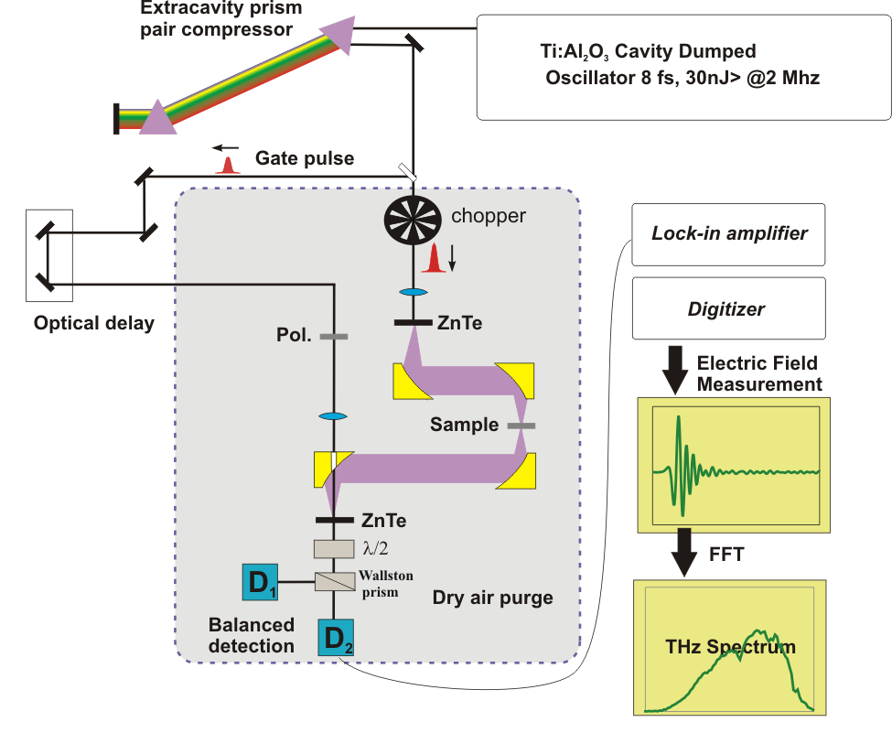

As shown in the above diagram the infrared beam from the laser is divided into two parts using a beam splitter. About 75% of the beam (pump beam) is focused onto a 100μm thick GaP crystal, which generates THz radiation via optical rectification. When a femtosecond laser delivers the applied electric field, the spectral bandwidth associated with such short pulses is very large. The mixing of different frequency components produces a bating polarization, which results in the emission of electromagnetic waves in the terahertz region. The diverging THz radiation from the crystal is collected, collimated, and refocused on a second GaP crystal using the four gold coated, paraboloidal mirrors. The other 25% is of the IR beam (gating beam) is focused on a second crystal for electro-optic sampling of the THz radiation. Since the gating beam is ultra short optical pulses there is only a short time interval in which the electric field associated with the THz beam can influence the light. The electric field causes a polarization on the gating beam in the nonlinear crystal. The gating pulse beam from the crystal is passed through a quarter-wave plate and a Wollaston prism, which splits the beam into two parts with different polarization that is vertical and horizontal. These two beams are fed into two biased photodiodes of balanced detectors. Any imbalance between the two detectors will lead to a net signal. The pre-amplified linear output of the detector is connected to a lock-in amplifier. Using an optical chopper modulates the pump beam. The amplified signal is digitized and transferred to a computer for recording and analysis. The digitized signal is the electric field of the THz radiation as a function of time. Fourier transform of this time domain signal yields the amplitude spectrum in the frequency domain.
Afterwards I was working on learning to cast polystyrene that is dissolved in toluene to produce nice little cylinders of the right smoothness and thickness.
After a number of trials, the procedure that produced one that finally good is: I measured 0.4738g of polystyrene and then added 5ml of toluene. After it was completely dissolved, I filled the casts with the solution. I let it evaporate for about 3hrs and the added more solution filling it up and I let it evaporate overnight. The casts I used:
After this I then leant how to purify quantum dots since what we had are the raw dots with a lot of impurities. Here is an example of one of my many purification procedures: Weighed 7.5532g of Indium doped (CdSe)ZnS. Then added 20 ml of toluene and heated it up a bit with the heat gun to aid in the melting. When the solid had dissolved, I centrifuged the solution to speed. Then poured out the liquid. I then poured half of the liquid into another tube. I added equal volumes of methanol to what was already in the tube (13ml). Centrifuged the two tubes for 10 minutes. Afterwards, I poured the liquid out, (now we need the solid not the liquid). Afterwards added 10 ml of toluene to both tubes dissolved it then added 10 ml of methanol to both tubes. Centrifuged again for 10 minutes and poured the liquid out. Added 3ml of toluene to one of the two tubes dissolved the solid then poured it into the other beaker and dissolved it in the solution. Then I added 0.3296g of polystyrene. Put the solution into the casts, dissolved for about 3 hours and the refilled the cast and let it evaporate overnight. I also did the same for tin doped samples. The diagram below shows the casts from polystyrene only, undoped, indium and tin doped samples. The color variation is due to the difference in concentration of the quantum dots in each sample.
We put these into the time domain spectrometer for the terahertz measurement. The polystyrene is transparent in the terahertz region so only the spectroscopy for the quantum dots us shown. The results we got:

The main feature in the THz absorbance spectra of the undoped quantum dots is a strong resonance at ∼5.75 THz. This strong absorbance peak is due to a coupled mode between longitudinal optical phonon and transverse optical phonon modes. The indium-doped sample has a peak at ∼5.8, not a big difference and the peak is not that difference in its width either. However, tin shows a bigger difference. The resonance peak is shifted to ∼ 6.1 and the band is broader. The most probable origin of the broad spectral feature of the tin doped sample is the presence of coupled plasmon-phonon modes.
Also the refractive index of the three is shown above. They all decrease at their respective resonances but tin doped quantum dots decrease the least.
What is a quantum dot? A quantum dot is a special class of semiconductors that are very small ranging from 2-10 nanometers in diameter. Excitons have an average physical separation between the electron and hole, referred to as the Exciton Bohr radius. In bulk, the dimensions are of the semiconductor are so much greater than the Exciton Bohr radius allowing the exciton to extend to its natural limit. However, if the size of a semiconductor crystal becomes small enough that it approaches the size of the material’s Exciton Bohr radius then the electron energy levels can no longer be treated as continuous, they must be treated as discrete, meaning that there is a small and finite separation between energy levels. This situation of discrete energy levels is called quantum confinement and the material does not resemble bulk but instead is called a quantum dot. This has large repercussions on the absorptive and emissive behavior of the semiconductor material.
The usefulness of quantum dots comes from their peak emission frequency’s extreme sensitivity to both the dot’s size and composition, which can be controlled using engineering techniques. The tunable band gap of quantum dots allows the creation of products with unique optical and electronic properties and a broad range of emission frequencies. The quantum dots have a lot of applications. Currently, products in the markets that are being produced include white light emitting diodes and LED color technology, a range of security and marking products including night vision pigments and inks, photovoltaic, medical devices, bio-reagents, thermoelectrics and many more fields.
Doping is the process of intentionally introducing impurities to a semiconductor in order to change its electrical and optical properties. The impurities are dependent upon the type of semiconductor. Doping is very important for tuning quantum dots so that they have the properties required for a particular task, which is very important in the industry. Doped quantum dots because of their tenability can lead to an improvement in creating new technologies in may fields including life sciences, photonics and telecommunications and solar cells.

