notes-7.

7. Finite square well problems in 1D--bound states and scattering states
Constant potential wells, potential barriers and delta potentials

Consider a finite square well which has depth of -V₀ (V₀>0) between -a and +a and zero outside this range. We will solve the eigenvalue problem.

7.1. The potential is symmetric, so we have even solutions and odd solutions. Use continuity of the wavefunction and its derivative at x=a, the eigenvalue equations are

even solution $κ=q\text{tan}\text{qa}$
odd solution $κ=−q\text{cot}\text{qa}$

where $q^{2}=\frac{2m}{ℏ^{2}}(V_{0}−|E|)$ and $κ^{2}=\frac{2m}{ℏ^{2}}(−E)$. The binding energy of course is negative.
Each equation above can be solved graphically. Manipulate the equation to dimensionless form by defining $λ=\frac{2m}{ℏ^{2}}V_{0}a^{2}$ and y=qa, one then leads to solving graphically the equations
$\text{tan}y=|\overline{λ}−y^{2}$/$y$, and $\text{cot}y={−|\overline{λ}−y^{2}}/y$, respectively.
The graphic solution of these two equations are indicated below:

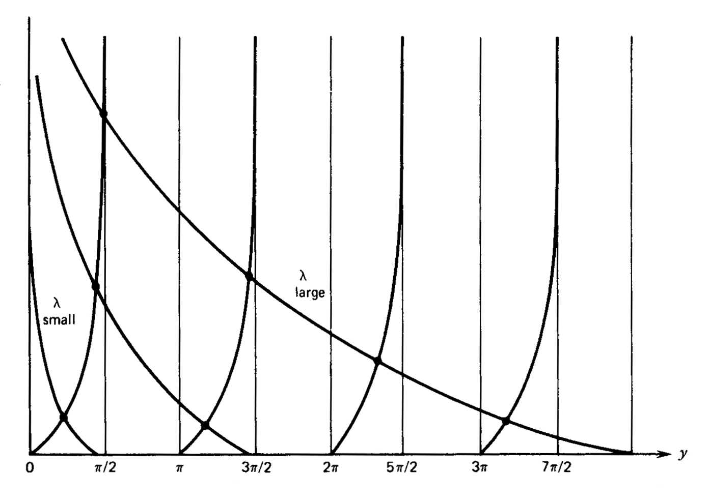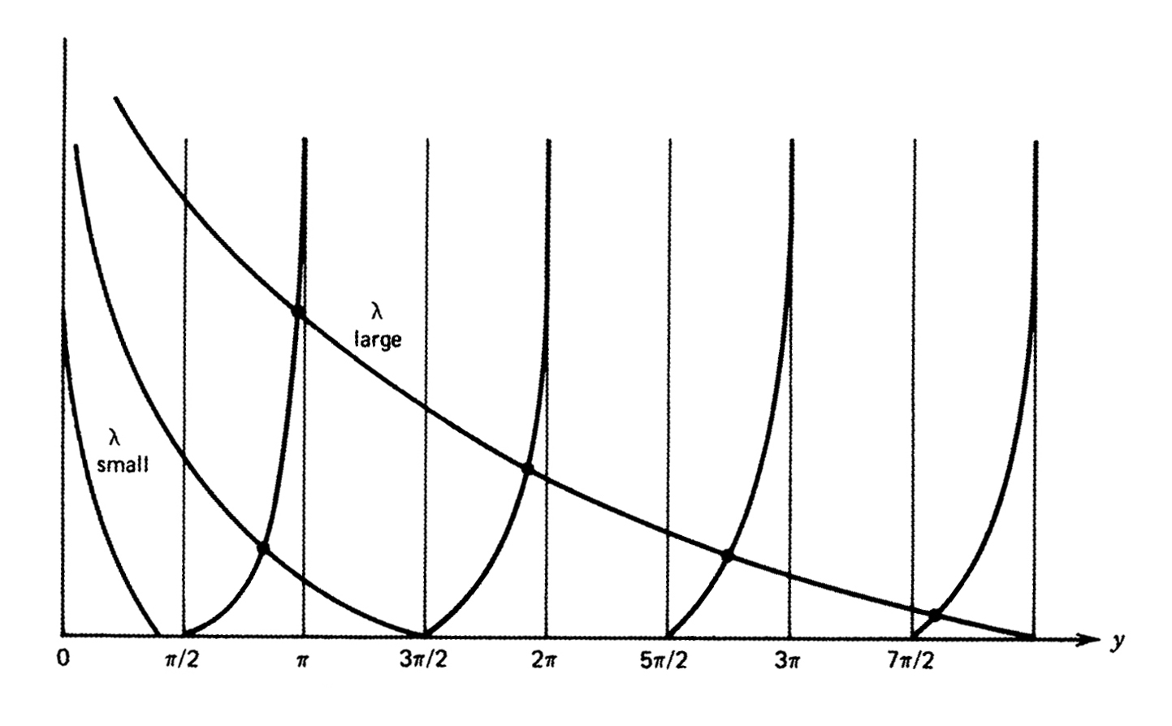

7.2. Scattering from a potential well and from a potential barrier
For a particle incident from the left of a potential barrier one can write the general form of the solution as
$\begin{matrix}u(x)=e^{\text{ikx}}+Re^{−\text{ikx}} & x<−a \\ \begin{aligned}u(x)=Ae^{\text{iqx}}+Be^{−\text{iqx}} \\ u(x)=Te^{\text{ikx}}\end{aligned} & \begin{aligned}−a<x<a \\ a<x\end{aligned}\end{matrix}$

By matching the boundary conditions at x=-a and x=a, one can solve the reflection amplitude R and the transmission amplitude T to get
$\begin{matrix}\begin{aligned}R=ie^{−2\text{ika}}\frac{\left(q^{2}−k^{2}\right)\text{sin}2\text{qa}}{2\text{kq}\text{cos}2\text{qa}−i\left(q^{2}+k^{2}\right)\text{sin}2\text{qa}} \\ \end{aligned} \\ T=e^{−2\text{ika}}\frac{2\text{kq}}{2\text{kq}\text{cos}2\text{qa}−i\left(q^{2}+k^{2}\right)\text{sin}2\text{qa}}\end{matrix}$
where k and q are the wave vectors in the region of V=0 and V=-V₀ region, respecively.

Note that at $\text{sin}2\text{qa}=0$, the transmission coefficient is a maximum--- resonance.
wave properties: occurrence of total transmission under some "resonance" condition.

tunneling phenomena for a potential barrier: For the case where the incident energy is less than the top of the barrier, the particle can tunnel to the other side. This is one of the most important consequences of quantum mechanics. To get the transmission coefficient, replace q by $iκ$ in the expressions above. The tunneling probability is given by

${\left|T\right|}^{2}=\frac{{\left(2kκ\right)}^{2}}{{\left(k^{2}+κ^{2}\right)}^{2}{\text{sinh}}^{2}\text{ 2}κa+{\left(2kκ\right)}^{2}}$
For large $κa$, the tunnelling probability above can be simplified to
$|T|^{2}=(\frac{4kκ}{k^{2}+κ^{2}})^{2}e^{−4κa}$
That is, the tunneling probability decreases exponentially. For a general potential, the exponential factor is replaced by $\text{exp}\left\{−2\int_{a}^{b}{\text{dx}\sqrt{(2m/{ℏ^{2}}[V(x)−E]}}\right\}$ where V(a)=V(b)=E, with a and b are the two turning points.

7.3. Delta function potentials--
(a) for $V(x)=−\frac{ℏ^{2}λ}{2\text{ma}}δ(x)$
(b) for $V(x)=−\frac{ℏ^{2}λ}{2\text{ma}}[δ(x−a)+δ(x+a)]$
More from homework assignment

(c) scattering : in the homework

7.4. Periodic potential-- the existence of energy gap

If the potential satisfies
$V(x+a)=V(x)$
then $H(x+a)=H(x)$

We will show that the solution $HΨ(x)=EΨ(x)$ can be written in the general form
$Ψ(x)=\text{exp}(iβx)u(x)$
where $u(x+a)=u(x)$
This is called the Bloch's theorem, or more generally, the Floquet theory.

Let $D_{a}$is a translation operator such that
$D_{a}f(x)=f(x+a)$
Clearly, for the periodic potential we have $[H,D_{a}]=0$ and the eigensolution $Ψ(x)$ should be the simultaneous solutions of both operators.

Let $D_{a}Ψ(x)=λ_{a}Ψ(x)$
By requiring that the norm be conserved under the translation,
$λ_{a}=\text{exp}(iβa)$;
thus $Ψ(x+a)=\text{exp}(iβa)Ψ(x)$

Next we make the ansatz $Ψ(x)=\text{exp}(iβx)u(x)$
or $u(x)=\text{exp}(−iβx)Ψ(x)$

$D_{a}u(x)=u(x+a)=e^{−i(x+a)β}Ψ(x+a)=e^{−i(x+a)β}e^{iβa}Ψ(x)=u(x)$

Thus the condition $u(x+a)=u(x)$ is proved.

Solution in a periodic delta potential
$V(x)=\frac{ℏ^{2}}{2m}\frac{λ}{a}\sum_{−∞}^{∞}{δ(x−\text{na})}$
We will show that the allowed solution has to satisfy the equation
$\text{cos}βa=\text{cos}\text{ka}+\frac{1}{2}λ\frac{\text{sin}(\text{ka})}{\text{ka}}$
Since the left hand side is bound between -1 and +1, the allowed values of k are restricted. For values of k that this equation can be satisfied, $E=ℏ^{2}{k^{2}}/2m$ gives the allowed energies. The forbidden region gives the energy gap. This leads to the band structure in periodic potentials. Here is a plot of the right-hand side of the above eq vs ka.
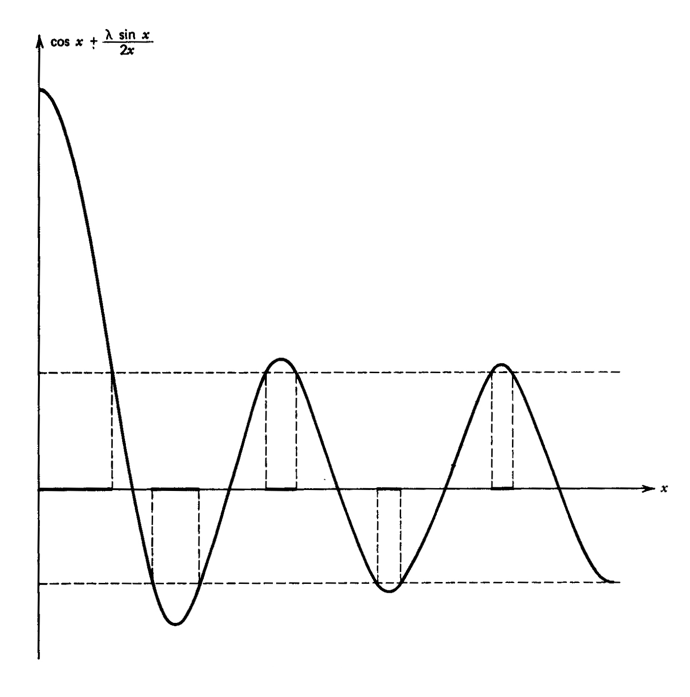

------------------------------------------------------------------------------------------------

Homework 7

( I have removed the first three questions here).

7.4. For the potential
$V(x)=−\frac{ℏ^{2}}{2m}[δ(x−a)+δ(x+a)]$
calculate the eigenvalue for the even symmetry state and for the odd symmetry state. Do the calculations for a range of the parameter a, and show that there is always an even solution. For the odd symmetry, there will be no bound state for small a. Graph or sketch the energies of the two states vs a.

7.5. The bound state wavefunction for the potential
$V(x)=−\frac{ℏ^{2}}{2m}δ(x)$ (1)
has been solved in the class. We want to solve the eigenstates of the potential

$V(x)=−\frac{ℏ^{2}}{2m}[δ(x−a)+δ(x+a)]$ (2)
approximately. Let $u_{1}(x)$ and $u_{2}(x)$ be the normalized eigensolutions of a single delta potential at x=-a and x=a, respectively. Let the eigensolution of eq. (2) be expressed as

$Ψ^{±}(x)=N^{±}(a)[u_{1}(x)±u_{2}(x)]$

(a) Calculate the normalization constant $N^{±}(a)$ analytically.
(b) Next evaluate the expectation values $U^{±}(a)\text{=<}Ψ^{±}|H|Ψ^{±}>$.
(c) Compare graphically the values $U^{±}$ obtained in (b) with the exact solutions obtained in problem 7.4.
This exercise can be viewed as an elementary model of H₂⁺ ion.

7.6. Calculate the transmission coefficient T at any energy E for the potential given in eq. (1) of problem 7.5.
=============================================================

7.1. (a) Carry out the graphic solution for the finite square well problem. Note that the energies depend on $V_{0}a^{2}$ only. Find the first four eigenvalue solutions for $λ=1,3,6,\text{10}$.
(b) Now we want to compare the eigenvalues for finite potential vs the infinite square-well potential obtained in note-1. First measure the energies from the bottom of the potential well. Rescale each energy in the form of the infinite square well
$E=\frac{ℏ^{2}α_{n}^{2}π^{2}}{2m(2a)^{2}}$
(Note that the width is 2a in this problem.) Compare $α_{n}$ with n for the first four states calculated in (a) and show that $α_{n}<n\text{.}$(Explain why?) Show your results graphically.

7.2. The binding energy of a deuteron is known to be 2.2 MeV. Treat deuteron as a proton and a neutron interacting in a 1D square well potential and that the width of the potential well is 2 fermi, calculate the depth V₀ in MeV. Note that deuteron has only one bound state. ( I do not need accuracy to more than 2 figures.)

7.3. In this exercise you will calculate the transmission coefficent as the scattering energy E is increased for a potential barrier.

For the potential barrier of width 2a and height V₀, calculate the transmission coefficient as the energy is varied from below the barrier to way above the potential. Plot your results. For simplicity, use m=1, $ℏ=1,V_{0}$=

